|  |  |  |
| --- | --- | --- |
|  | **Example Neural Networks Worksheet** |  |

# 

## For the following questions you will make observations of running genetic algorithms.

## 

## MarI/O

[MarI/O](https://www.youtube.com/watch?v=qv6UVOQ0F44)

* In a genetic algorithm “fitness” is how close a solution is to solving a problem. Explain how MarI/O represents fitness?

It represents it by showing how far Mario gets toward the end of the level.

* What role does a Mushroom, Coin, or Yoshi play in this fitness equation?

They show the neural network what Mario can’t stand on. They have no meaning.

* In a genetic algorithm “chromosomes” represent actions that can be used to solve a problem. What does MarI/O use as chromosomes?

It uses green and red lines with white boxes that represent the actions that work for the

Aside from losing a life in a traditional way, MarI/O can be killed in another way that can happen much faster. MarI/O dies from lack of movement quickly if fitness does not go up.

MarI/O dying from this helps the simulation to run much faster, but it also is a critical flaw. Explain why MarI/O cannot beat Yoshi’s Island #3 using the map below as a reference.

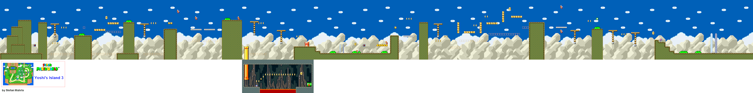

* Explanation:

There are moving platforms that you have to wait for and the program does not allow Mario to stand still without moving so it kills him thus not allowing him to complete the level.

[MarI/O Follow Up](https://www.youtube.com/watch?v=iakFfOmanJU&t=5s)

* What did MarI/O discover and why is it important?

It discovered a glitch and this is important as it shows that the neural network can see different things other than humans.

* Could you use the same algorithm structure in MarI/O to play a first person RPG? Explain your answer:

No because the time constraint would probably cause it to not survive too long.

[MarI/O Kart](https://www.youtube.com/watch?v=S9Y_I9vY8Qw)

* What is different about how MarI/O calculates fitness in MarI/O Kart?

Marl/O uses how far you last in a level compared to Marl/O Kart which uses how fast you complete the game.

* What other games could this framework be used to play?

Any other speed run games for games like Mario Kart maybe as race games.

## MariFlow

[MarioFlow](https://www.youtube.com/watch?v=Ipi40cb_RsI)

* What machine learning library does MariFlow use?

TenserFlow

* How has MariFlow learned how to drive?

It has learned from example.

* How is MarI/O different from MariFlow in how it learns?

MarioFlow learns from example instead of a network of connections.

* What is different about a feed forward neural network and a recurrent neural network?

In a feed forward neural network data flows from one layer to the next. In a recurrent neural network each neuron remembers what it learned from the one before it.

* What happens when MariFlow runs into a situation that it has never seen before? Can it solve the situation? Why?

It starts to predict what buttons would be best to press to get over the problem. Yes because it uses his data to predict next.

* How can the network be taught to overcome situations that are not effective?

It can be taught through more training videos as it helps teach the network how to predict the next moves.

## MarIQ

[MarIQ](https://www.youtube.com/watch?v=Tnu4O_xEmVk)

* What makes MariFlow different from MarIQ?

MariFlow only uses human input and MarIQ teaches itself.

* What are the only means that MarIQ can learn?

It can only learn by receiving reward and punishment scores.

* How does the standard built in AI make decisions in Mario Kart?

It had plugged in cards determining where it would need to push each button to go in each direction.

* Explain the try hard percentage and what role it plays in decision making:

Try Hard percentage is how good its current strategies are and it determines whether it will listen to the neural network completely or partly.

* What does the term generalization mean and how did MarIQ prove that it had achieved this?

Generalization means that a network can apply what it learned to other situations. It proved this by being relatively good at different courses that it has never seen before.

## Solving Snake with Evolution

[Snake](https://pbinggeser.github.io/snake-ai/)

* What do you believe are the most important traits that this snake simulation is prioritizing?

I think the most important traits are heading to the food and not hitting itself.

* What would happen in this simulation if the computer made simple time that a snake has survived the most important aspect of the simulation?

That snake would probably be ok at the game but not the best compared to others which evolved all the different traits.

## More Evolution

Observe the following examples of a genetic algorithm that simulate a living organism. Choose one simulation to look at more in depth and answer the following questions for that simulation.

* + 1. [Evolution Simulator](https://www.openprocessing.org/sketch/377698) (Creatures with muscles and bone)
       1. [Part #1](https://www.youtube.com/watch?v=GOFws_hhZs8)
       2. [Part #2](https://www.youtube.com/watch?v=31dsH2Fs1IQ)
       3. [Part #3](https://www.youtube.com/watch?v=IVcvvqxtNwE&t=225s)
       4. [Part #4](https://www.youtube.com/watch?annotation_id=annotation_3154487001&feature=iv&src_vid=IVcvvqxtNwE&v=KrTbJUJsDSw)
    2. [Car Genetic Algorithm](http://rednuht.org/genetic_cars_2/)  (Cars with wheels)
    3. [Cambrian Explosion](http://www.cambrianexplosion.com/) (Worm, ring, quadruped, star)
    4. [Walkers](http://rednuht.org/genetic_walkers/) (Bipedal humanoid creatures)
    5. [Evolution Simulator Game](https://keiwan.itch.io/evolution) (You design the creature)
* Which simulation did you choose?

I chose the car genetic algorithm.

* What are the settings you are allowed to change?

I can only change the track and how fast the simulation goes.

* What traits does a successful creature have in your evolution simulation? How many generations did it take to get to this point?

They have a pointed top of the car with medium wheels. It took about 50 generations to get there.

* Do a long term run of this simulation. Check in on the simulation over the course of time.
  1. Do a screenshot of the starting configurations and creature.

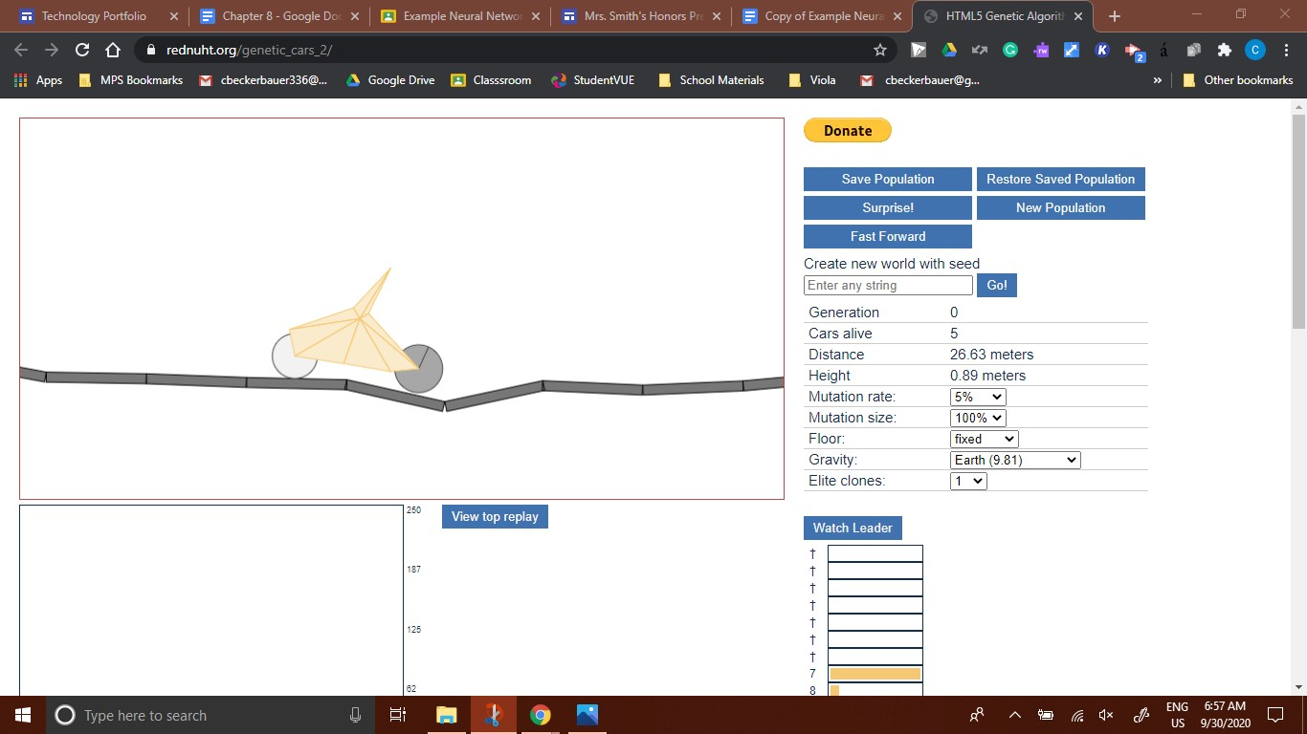

* 1. Do another after one hour.

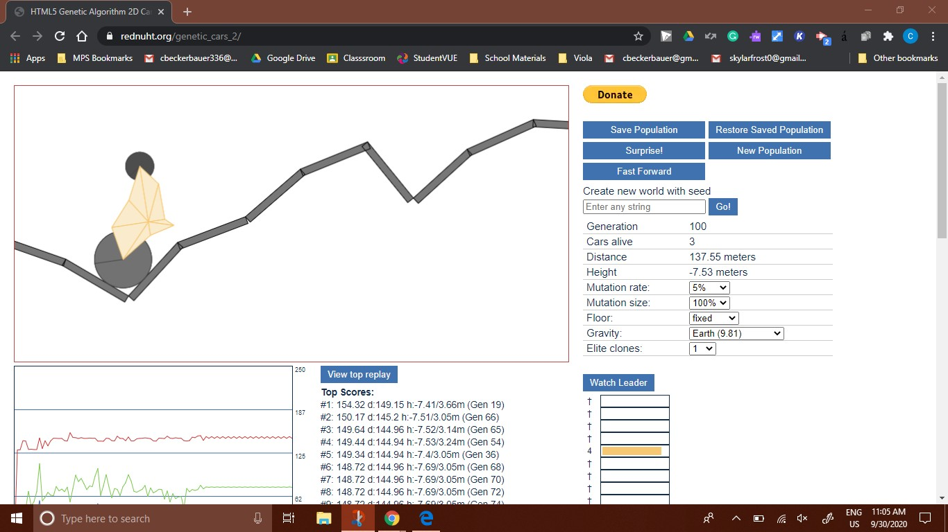

* 1. Finally, let the simulation run overnight while you sleep and take a last screenshot. Bring your creature to school to share what it can do the next day.

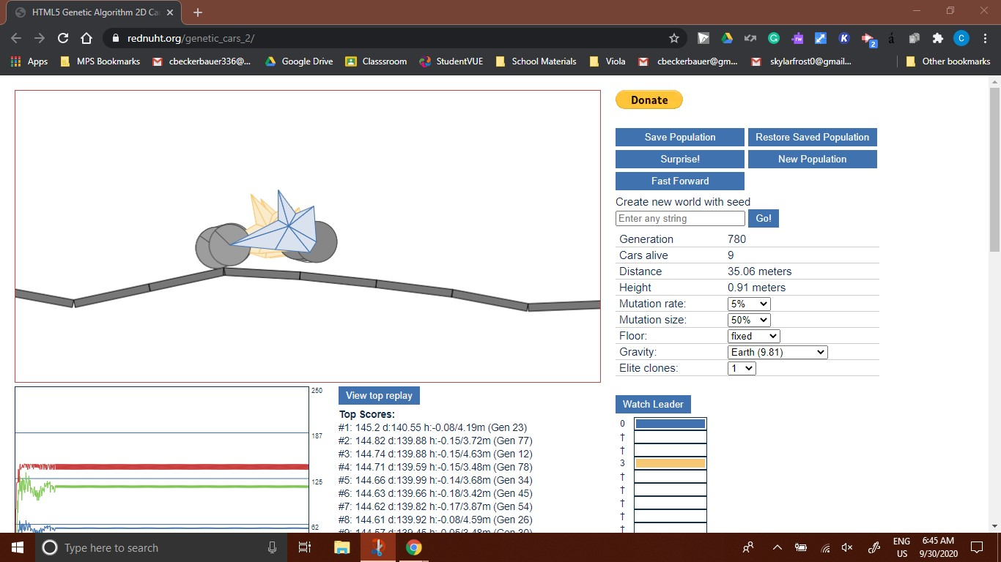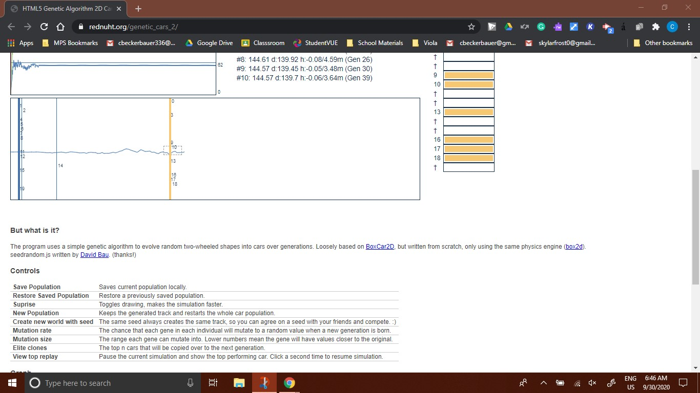

* 1. What changes occured that made this creature more successful than the starting creature? Explain what works better for accomplishing the improved mobility.

The car ended up having a medium distance between the wheels of it, the wheels were about medium in size, and it had a pointed top. The medium distance and wheel size helped it move fast and get over most obstacles. The pointed top helped it get tipped over when it crashed allowing it to go farther.